Project Name: Learn2Play



Problem Statement (why we want to make this project)
- The absence of accessible, comprehensive, and engaging resources for learning and excelling in different sports restricts the growth of aspiring athletes and sports lovers.
- Conventional learning methods tend to be disjointed, with limited access to expert guidance, immersive training experiences, and personalized feedback.

Introduction to Learn2Play
Unlock Your Athletic Potential
Learn2Play is an interesting platform that will teach you in more an interactive way to play your sport & pursue your passion
Training & learning sports on Online platform is now much easier

What is Learn2Play
Learn2Play, an innovative online platform designed to revolutionize sports education.
Our mission is to assist athletes and sports enthusiasts at every level in achieving their fullest potential.
Whether you're just starting out or already experienced, Learn2Play provides programs that fit your needs.
Our easy-to-follow modules cover various sports, making sure there's something for everyone.
With learn2play, you're learning in a supportive environment that values your journey.
Learn2play also helps users pursue their professional sports dreams by offering detailed roadmaps and expert evaluations.
Learn2play is a platform that allows mentors to create online classes whereby they can store the course materials online; manage tasks, drills, practice and exercise; monitor due dates; grade performance and provide players with feedback all in one place.

Objectives
- The goal is to create a comprehensive online platform that provides users with tools, knowledge, and support to learn and excel in various sports.
- Offering detailed coverage of multiple sports, including methods, techniques, strategies, rules, regulations, and terminology.
- Provide roadmaps for users to pursue any sports professionally.

Methodology
To build the good web sports learning platform we have to follow the methodology like:

1. Research & Planning
- Conduct market research to identify user needs and preferences.
- Define project goals and create a detailed project plan.

2. Content Development
- Collaborate with sports experts to create comprehensive content for each sport.
- Develop instructional course materials, videos and tutorials for beginners.

3. Technology Integration:
- Create video analysis tools for performance feedback.
- Establish remote teaching using tools like Zoom for live coaching sessions. Try to make on that tool on Learn2play platform.
- Separate Window for Mentor, Players & Admin.

4. Platform Development
- Create a user-friendly interface for easy navigation.
- Incorporate content and tools into the platform.
- Conduct through testing for functionality and user experience.

DFD : 0-Level DFD

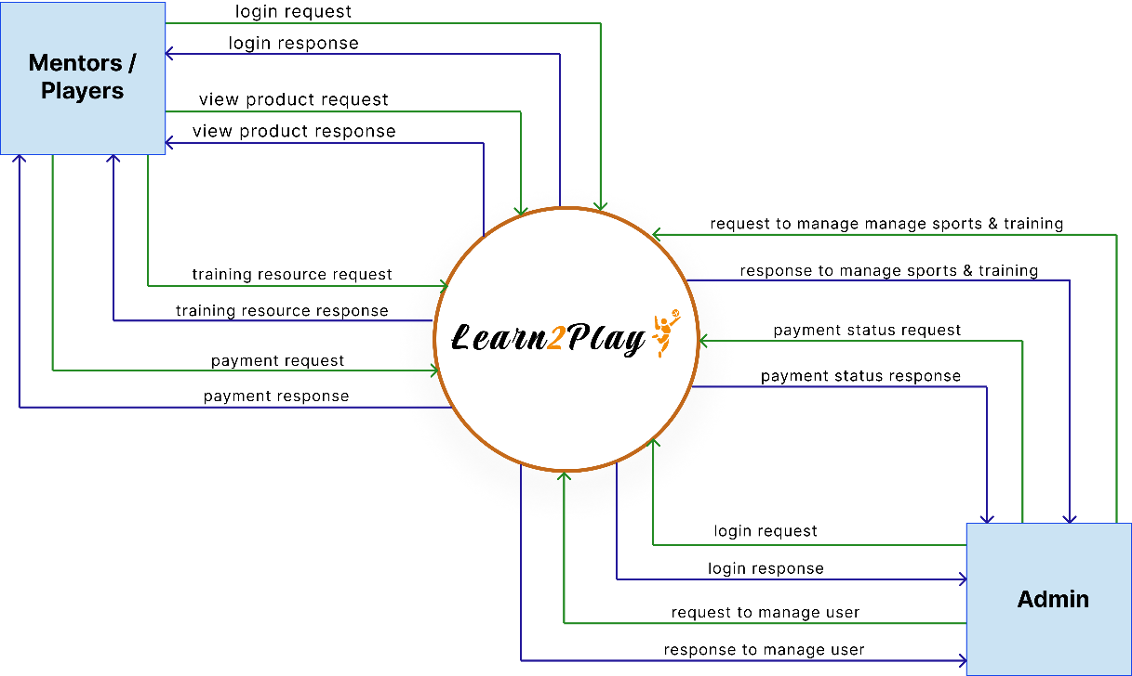

DFD: 1-Level DFD
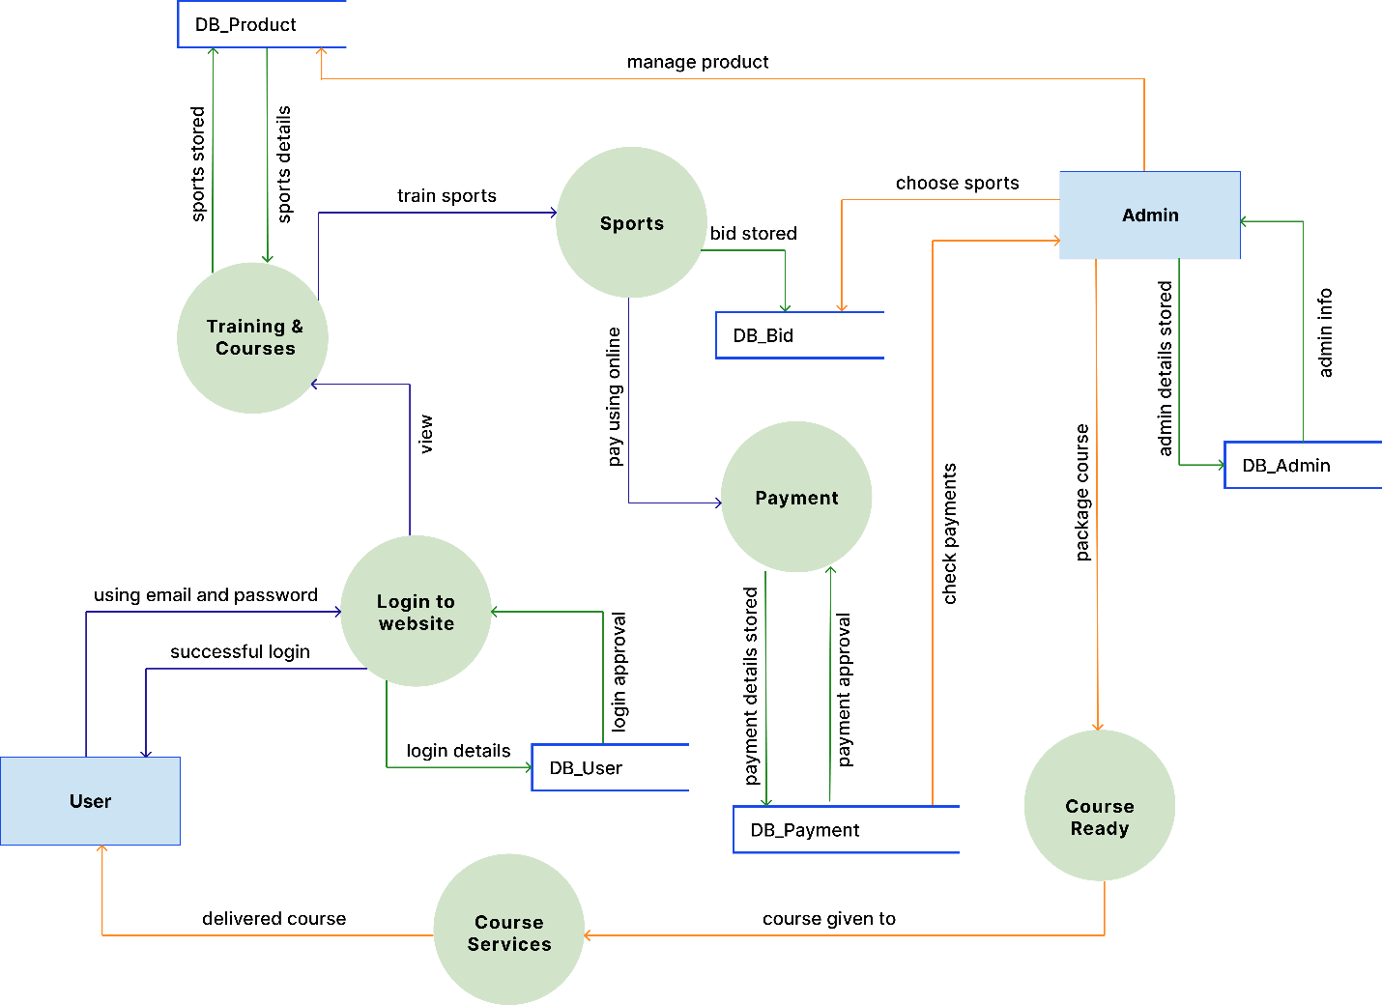

ER Diagram:

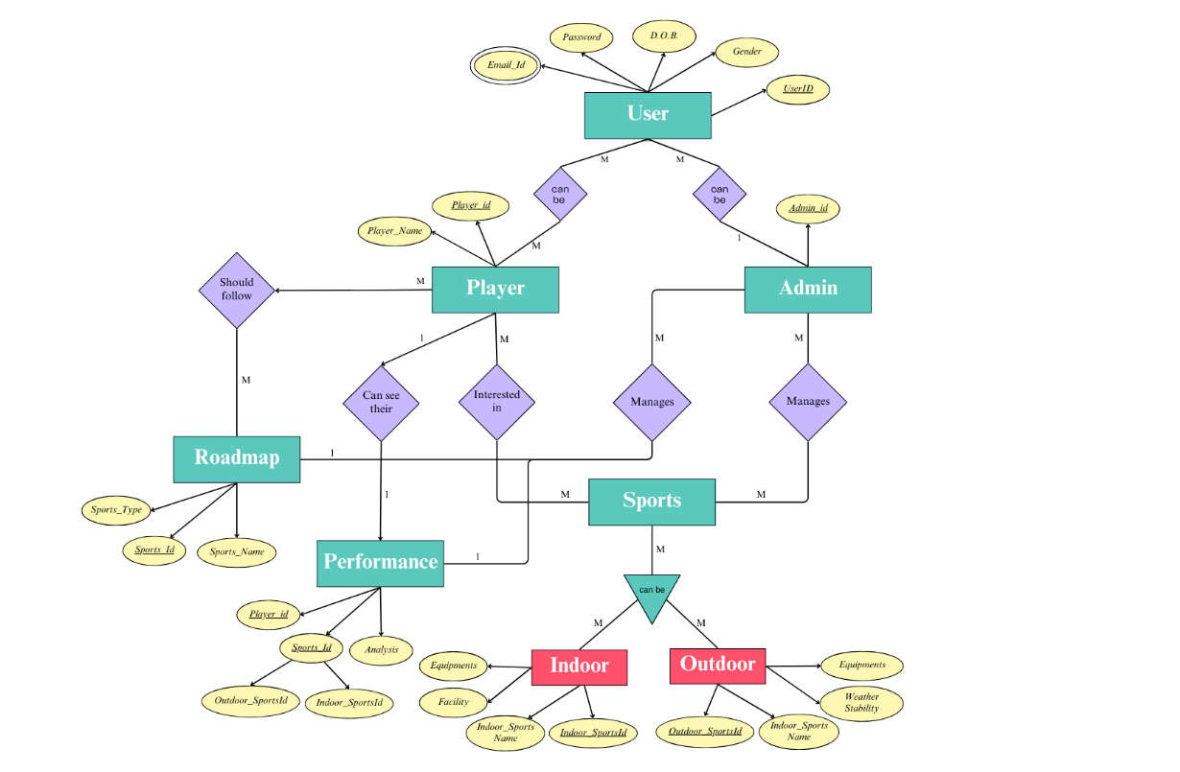

Application
- The platform will serve as a comprehensive resource for learning various sports but mastering it requires real-world practice.
- It will be used by beginners, amateur athletes, coaches, and sports enthusiasts.
- Experts will evaluate user performance and provide guidance on pursuing sports professionally
Key Features:

- User Registration and Profiles: Create profiles with sports interests and skill levels.
- Courses and Tutorials: Offer video lessons, practice drills, and interactive quizzes for different sports.
- Live Training Sessions: Schedule live sessions and webinars with professional coaches and athletes.
- Training Programs: Provide structured training programs with progress tracking and personalized feedback.
- Community and Forums: Enable discussions, experience sharing, and seeking advice.
- Resource Library: Provide articles, e-books, and training materials on various sports topics.
- Performance Analytics: Offer tools for performance analysis, video reviews, and fitness assessments.

Benefits:

- Access to expert knowledge and training programs.
- Personalized training with progress tracking.
- Community engagement and support.
- Convenient access via a website.

References
- P. L. Williams, J. M. Jones, and K. T. Simon, "The role of digital platforms in sports education and coaching," Journal of Sports Education Technology, vol. 15, no. 3, pp. 123-136, Mar. 2023.
- R. S. McDonald, "Virtual Reality in Sports Training: A New Era," International Journal of Sports Science & Technology, vol. 22, no. 5, pp. 78-85, May 2022.
- T. H. Weber, "Video analysis and feedback mechanisms in athletic training," Journal of Performance Evaluation in Sports, vol. 18, pp. 45-55, Feb. 2021.
- Online Sports Academy, https://onlinesportsacademy.com/
- iSportz: LEARNING MANAGEMENT SYSTEM (LMS), https://isportz.co/sports/sports-learning-management-system/
Summary
- Learn2Play aims to change how people learn sports by combining expert advice with easy-to-use tools.
- It provides detailed information about different sports and gives personalized feedback.
- Users can learn at their own speed and get professional evaluations to help them reach their sports goals.

Project Development

What I want to build & try to add some beneficial functionality the on the platform, make it easy use for both mentor & players.

🏗️ Structure of Website Flow (Sport-Based Approach)

1. Landing/Home Page
- Hero Section: “Master Your Sport, Learn from the Best”
- Brief: What is Learn2Play?
- Featured Sports (e.g., icons for Cricket, Football, Tennis)
- CTAs:
  - "Choose Your Sport"
  - "Join as a Mentor"
  - "Start Learning"

2. Sport Selection Page
/sports
- Grid/List of available sports
- Each card: icon/image + brief description
- Clicking leads to a dedicated sport page:
  - /sports/cricket
  - /sports/football
  - /sports/tennis

3. Individual Sport Page (e.g., Cricket)
/sports/cricket
- Intro: “Why Learn Cricket?”
- Available Programs:
  - Beginner, Intermediate, Advanced
- Available Mentors (cards with ratings, skills, followers)
- Live Sessions Calendar (filtered for Cricket)
- Popular Courses
- Video Library & Drills
- Upcoming Tournaments or Events (if any)
- Player Stories & Achievements
✳ Repeat this layout for each sport

4. Course Page (Sport-Specific)
/sports/cricket/courses/batting-basics
- Course overview
- Coach profile
- Modules:
  - Videos, Drills, Assignments, Quizzes
- Student Reviews
- Progress tracking
- Enroll / Continue Course

5. Mentor Hub
/mentors
- Filter by sport, skill level, rating
- Mentor Profiles:
  - Intro video, specialization, session booking
  - Courses Created, Reviews

6. Live Training
/live-sessions
- Filter by sport & level
- Join session / Set reminder
- Past sessions archive

7. Performance & Feedback
/performance
- Upload video for coach review
- Performance analytics (per sport)
- Personalized feedback
- Progress Reports

8. Community Zone
/community
- Sport-specific forums (e.g., Cricket Forum, Football Forum)
- Ask/Answer, Share Experiences
- Post practice videos for peer review

9. Resource Library
/resources
- Articles, eBooks, Rulebooks
- Sport-specific filters
- Search by tags: Techniques, Fitness, Career Roadmap

10. Profile Dashboard
Role-based:

Player Dashboard:
/dashboard
- Enrolled Courses (by sport)
- Progress, Live Sessions
- Feedback Reports
- Suggested Content

Mentor Dashboard:
/mentor/dashboard
- Courses Created
- Session Schedule
- Student Progress

Admin Dashboard:
/admin
- Manage Users, Courses, Reports

💡 Additional Suggestions
- Breadcrumb Navigation
Example: Home > Sports > Cricket > Batting Basics
- Dynamic Filtering
Inside course pages or mentor lists, let users filter by:
  - Difficulty
  - Video length
  - Equipment needed
- Integrated Career Roadmaps Add a tab in each sport page:
"Career Roadmap in Cricket" → Step-by-step guide to go pro.
- Spotlight Stories Short videos/interviews of learners or pros in each sport page to keep users inspired.
- Mobile-Friendly Design Essential for athletes who may access drills or videos while training outdoors.

Functionality:
Absolutely! Here’s a complete breakdown of functionalities to add to your Learn2Play platform — tailored to support sport-specific learning (like Cricket, Football, Tennis) and enhance usability for players, mentors, and admins.

🎯 Core Functionalities (For All Users)

1. 🔍 Sport Selection & Navigation
- Grid/List of available sports
- Redirects to dedicated sport pages
- Quick filters: Popular | Beginner-friendly | New

🧑‍🎓 Player-Side Functionalities

2. 📚 Course Enrollment
- Browse sport-specific courses
- Course preview, instructor info, difficulty tags
- Enroll button & progress tracker

3. 📹 Video Library & Drill Bank
- Sport-specific videos (tagged: e.g., "Cricket – Bowling Drills")
- Bookmark, like, comment
- Downloadable PDFs & guides

4. 🏃 Practice Tracker
- Log drills completed
- Upload videos for feedback
- Set personal goals & milestones

5. 📈 Performance Dashboard
- Visual charts of improvement
- Stats for quizzes, assignments, video submissions
- Feedback archive from mentors

6. 🗣️ Mentor Feedback Module
- Video review tool (with time-stamped comments)
- Written performance notes
- Rating & mentorship continuation suggestions

7. 📅 Live Sessions & Calendar
- Book sessions with mentors
- Calendar view of upcoming sport-specific live events
- Reminders/notifications

8. 🏅 Gamification
- Earn XP, badges for completing tasks
- Leaderboards (per sport, per region)
- Daily/weekly challenges

9. 🌐 Community Engagement
- Sport-specific discussion boards
- Peer practice video sharing & feedback
- Ask-a-mentor section

🧑‍🏫 Mentor-Side Functionalities

10. 🛠️ Course Builder
- Add lessons, drills, assignments
- Upload video + PDF content
- Quiz & test creation

11. 🎦 Live Session Hosting
- Schedule session
- Zoom/WebRTC integration
- Post-session feedback distribution

12. 📝 Student Evaluation
- Access to enrolled players' progress
- Annotated video feedback
- Leaderboard contribution tracking

13. 🧑‍🤝‍🧑 Mentor Collaboration
- Invite co-mentors
- Share lesson plans or co-host sessions

🛠️ Admin Functionalities

14. 👤 User Management
- Approve/reject mentors
- Manage player profiles, warnings, bans
- Track activity logs

15. 📦 Content Management
- Approve courses for publishing
- Monitor flagged content
- Feature top-rated courses/mentors

16. 📊 Analytics & Reporting
- Platform-wide usage stats
- Sport-specific trends (e.g., more users learning Tennis this month)
- Mentor performance insights

📲 Bonus Functionalities (for Better UX)

17. 🔔 Notifications
- For enrolled course updates, mentor replies, session reminders

18. 🌙 Dark Mode
- Better usability for night learners

19. 🌍 Multilingual Support
- Translate interface & subtitles

20. 📱 Mobile Responsive / App Support
- Touch-friendly drill cards
- Easy video uploading from phone camera

